# _LITfinalLOGO

# SUMMER EXAMINATIONS 2014

**Monday, 12th May 2014, 14.30 p.m. – 17.00 p.m.**

**KSDEM\_8\_Y2**

**Programme:** Bachelor of Science (Honours) in Software Development

**Stage:** Two

**Module:** Mathematics for Computing

**Time Allowed:** 2½ Hours

**Instructions:**

**1.** Answer **FOUR** of the following **FIVE** questions.

**2.** All questions are equally weighted.

**Additional Attachments Exam Materials to accompany this paper:**

1. Appendix A
2. Worksheet for Sieve of Eratosthenes

**Internal Examiner(s): External Examiners(s):**

Dr Oliver Hyde Mr. Brian Gillespie

**Q. 1**

**(a)**

A password is a sequence of eight characters, the first five being either an upper or a lowercase letter, the being a digit, and the final two coming from the set {!, £, $, %, ^, &, \*, (, ), \_, +, =, {, }, [, ], @, #, ?} of 19 other symbols occurring on a standard keyboard.

1. How many different passwords are there?

**(3 marks)**

1. How many are there if all the characters must be different?

**(3 marks)**

**(b)**

Use the Pigeonhole Principle to prove that if four different numbers are chosen from the set {1, 2, 3, 4, 5, 6}, at least one pair must add up to 7.

**(6 marks)**

**(c)**

1. Use the binomial theorem to find the first six terms, in ascending powers of *x*, of (1 + *x*)32.

**(3 marks)**

1. Use part (i) to estimate 1.0532.

**(2 marks)**

1. Calculate 1.0532, correct to five decimal places. Find the error in the estimate by subtracting the estimated value found in part (ii) from the correct value found in part (iii).

**(2 marks)**

**(d)**

Julia borrows €1,000 at an interest rate of 12% compounded annually.

1. How much does Julia owe after three years?

**(3 marks)**

1. In how many years will the debt grow to €2,000?

**(3 marks)**

**(Total 25 Marks)**

**Q. 2**

**(a)**

The Luhn algorithm is a checksum formula used to validate credit card numbers among other applications. The formula verifies a number against its included check digit, which is usually appended at the end number to generate the full number. This number must pass the following test:

1. From the first digit, double the value of odd-positioned digit; if the product of this doubling operation is greater than 9 (e.g., 7 × 2 = 14), then sum the digits of the product (e.g., 10: 1 + 0 = 1, 14: 1 + 4 = 5).
2. Take the sum of all the “doubled” digits.
3. Add to this sum the remaining digits (the digits in even positions, including the check digit).
4. If the sum modulo 10 is equal to 0 (if the sum ends in zero) then the number is valid according to the Luhn formula; else it is not valid.

Demonstrate whether the following are valid credit card numbers using the Luhn algorithm. If not, state what the check digit (the last digit) should be for that number to be a valid credit card number.

1. Visa 4012888888881881

**(4 marks)**

1. MasterCard 5105105105105105

**(4 marks)**

**(b)**

Use the Euclidean algorithm to find the greatest common divisor of each of the following pair of integers.

1. 8,265 and 2,926.

**(3 marks)**

1. 2,468 and 3,579.

**(3 marks)**

**(c)**

Use the Sieve of Eratosthenes to *list* all the primes less than 150.

|  |  |  |  |  |  |  |  |  |  |
| --- | --- | --- | --- | --- | --- | --- | --- | --- | --- |
|  | 2 | 3 | 4 | 5 | 6 | 7 | 8 | 9 | 10 |
| 11 | 12 | 13 | 14 | 15 | 16 | 17 | 18 | 19 | 20 |
| 21 | 22 | 23 | 24 | 25 | 26 | 27 | 28 | 29 | 30 |
| 31 | 32 | 33 | 34 | 35 | 36 | 37 | 38 | 39 | 40 |
| 41 | 42 | 43 | 44 | 45 | 46 | 47 | 48 | 49 | 50 |
| 51 | 52 | 53 | 54 | 55 | 56 | 57 | 58 | 59 | 60 |
| 61 | 62 | 63 | 64 | 65 | 66 | 67 | 68 | 69 | 70 |
| 71 | 72 | 73 | 74 | 75 | 76 | 77 | 78 | 79 | 80 |
| 81 | 82 | 83 | 84 | 85 | 86 | 87 | 88 | 89 | 90 |
| 91 | 92 | 93 | 94 | 95 | 96 | 97 | 98 | 99 | 100 |
| 101 | 102 | 103 | 104 | 105 | 106 | 107 | 108 | 109 | 110 |
| 111 | 112 | 113 | 114 | 115 | 116 | 117 | 118 | 119 | 120 |
| 121 | 122 | 123 | 124 | 125 | 126 | 127 | 128 | 129 | 130 |
| 131 | 132 | 133 | 134 | 135 | 136 | 137 | 138 | 139 | 140 |
| 141 | 142 | 143 | 144 | 145 | 146 | 147 | 148 | 149 | 150 |

**(4 marks)**

The prime-counting function π(*x*) gives the number of primes less than or equal to any real number *x*. The prime number theorem tells us that it may be *estimated* by *x*/ln(*x*). State the exact value of π(150) and its estimated value.

**(2 marks)**

**(d)**

Find the prime decomposition of each of the following numbers.

1. 12,321.

**(2 marks)**

1. 1,234,567 (note that this number has exactly two prime factors, both greater than 100).

**(3 marks)**

**(Total 25 Marks)**

**Q. 3**

**(a)**

*Dragon Age: Origins* is a role-playing video game published by Electronic Arts. One puzzle encountered by people who play the game is in the form of a structure made of multiple circular stones laid out in a pattern along the ground with broken columns surrounding the outside (see screenshot below).

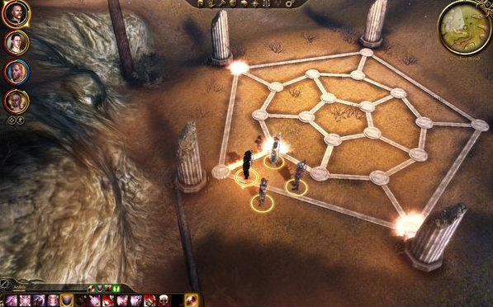

Successful completion of the puzzle requires the player to traverse the structure in a Hamiltonian cycle. Draw a graph of the structure, showing a Hamiltonian cycle solution to the puzzle on the graph.

**(8 marks)**

**(b)**

Draw binary trees to represent the following mathematical expressions.

1. (((2 + 9) – 7) × 6) ÷ 4

**(4 marks)**

$$\frac{-b+\sqrt{b^{2}-4ac}}{2a}$$

**(4 marks)**

**(c)**

In graph theory terminology, explain what is meant by an *Eulerian walk*.

**(1 mark)**

Explain why the following graph has an Eulerian walk and find one such walk.

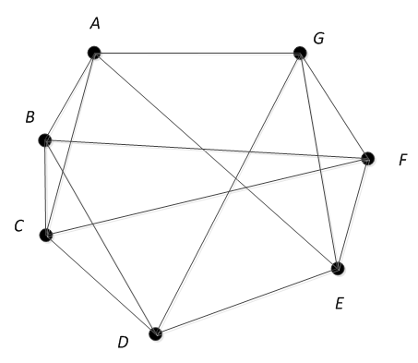

**(8 marks)**

**(Total 25 Marks)**

**Q. 4**

**(a)**

The following text is encoded using a Caesar cipher.

CGRQOTM UT CGZKX GTJ JKBKRUVOTM YULZCGXK LXUS G YVKIOLOIGZOUT GXK KGYE OL HUZN GXK LXUFKT.

Decipher the text.

**(5 marks)**

|  |  |  |  |  |  |  |  |  |  |  |  |  |  |
| --- | --- | --- | --- | --- | --- | --- | --- | --- | --- | --- | --- | --- | --- |
| **Ciphertext** | A | B | C | D | E | F | G | H | I | J | K | L | M |
| **Plaintext** |  |  |  |  |  |  |  |  |  |  |  |  |  |

|  |  |  |  |  |  |  |  |  |  |  |  |  |  |
| --- | --- | --- | --- | --- | --- | --- | --- | --- | --- | --- | --- | --- | --- |
| **Ciphertext** | N | O | P | Q | R | S | T | U | V | W | X | Y | Z |
| **Plaintext** |  |  |  |  |  |  |  |  |  |  |  |  |  |

**(b)**

Explain, with the aid of a diagram, the concept of private key cryptography (symmetric key cryptography). Include two advantages and two disadvantages of the method as part of your explanation.

**(8 marks)**

**(c)**

Suppose I want to send a message one letter at a time, using the RSA cryptosystem with the primes *p* = 5 and *q* = 7, and just send the letters A through Z as numbers 1 through 26 respectively.

1. If I use the encryption key *e* = 5, what is the smallest positive number you can use for the decryption key *d*?

**(2 marks)**

1. Using public keys *n* = 5×7 = 35 and *e* = 7, I send you the following message: 02 10 01 09 06 04 03 10 06 04 08 10. Decipher the message using the value of *d* you found in part (i).

**(6 marks)**

1. Give two reasons why you should not want to send a sensitive message using this scheme.

**(4 marks)**

**(Total 25 Marks)**

**Q. 5**

**(a)**

Using propositional logic, including the rules shown in Appendix A, prove that the argument is valid. Use the statement letters shown.

*If security is a problem, then regulation will be increased. If security is not a problem, then business on the internet will grow. Therefore if regulation is not increased, then business on the internet will grow.* (Statement letters: *S, R, B*).

**(6 marks)**

**(b)**

Using the predicate symbols shown and appropriate quantifiers, write each English language statement as a predicate well-formed formula.

*S(x)* is “*x* is a spy novel”.

*L(x)* is “*x* is a long”.

*M(x)* is “*x* is a mystery”.

*B(x, y)* is “*x* is better than *y*”.

1. All spy novels are long.

**(2 marks)**

1. Not every mystery is a spy novel.

**(3 marks)**

1. Only mysteries are long.

**(3 marks)**

1. Some mysteries are better than all spy novels.

**(3 marks)**

**(c)**

Three friends, one from Italy, one from Brazil, and one from Spain are driving together when they hear the following comment on the radio about the recent World Cup matches: “The top three countries were Spain, Italy, and Brazil. Either Spain outranked Italy, or Brazil came first, but not both”. After hearing that, the Italian said that even though he knew the standing of his country’s team, it was not possible for him to determine the ranking. The Spaniard, who did not listen to what the Italian just said, also said it was not possible for him to determine the ranking, even though he knew how his country’s team placed. The Brazilian, who heard everything but knew nothing about the matches, was able to determine the top three ranking. Which countries came in first, second, and third?

**(8 marks)**

**(Total 25 Marks)**

**Appendix A**

